**Restaurant Reservation System**

**Actors:**

- Restaurants/Hotel

Onboarding of new restaurants

Updates, like menu, onboarding new dishes, pricing, images etc.

Bookings

- User

Search the restaurant based upon location, Search based upon criteria like price range, their rating [food, ambience, staff hospitality, pricing] and occasion

Book it [Date, people, Lunch, Time, Special Occasion (like b'day, anniversary), Additional requests), Personnel details]

Check bookings

- Analytics

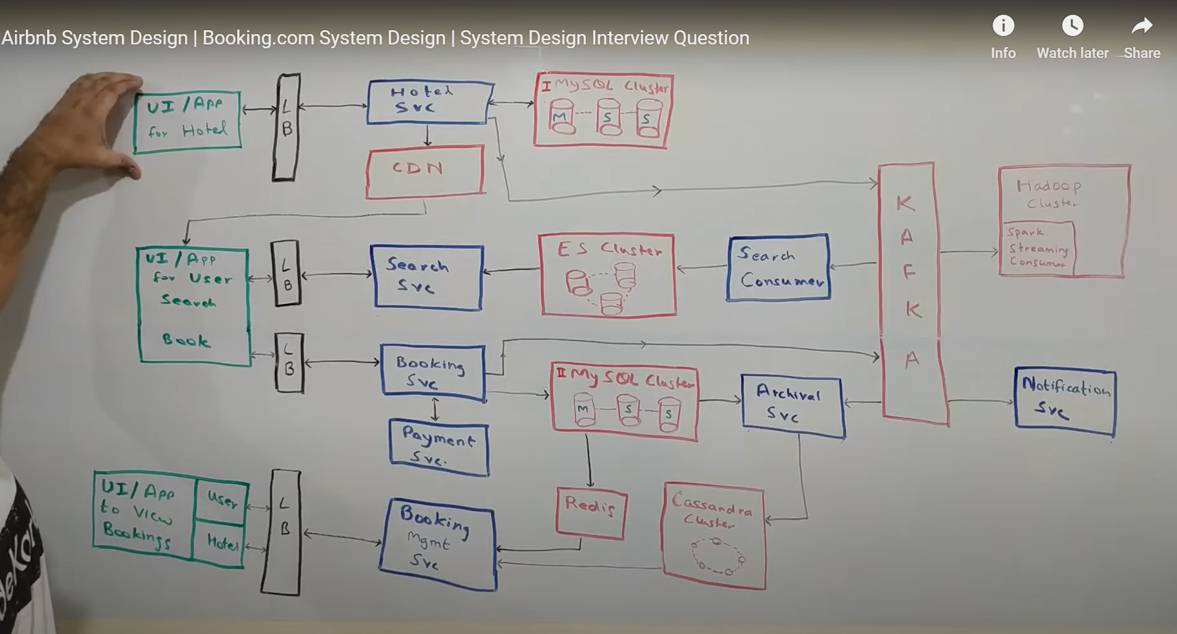

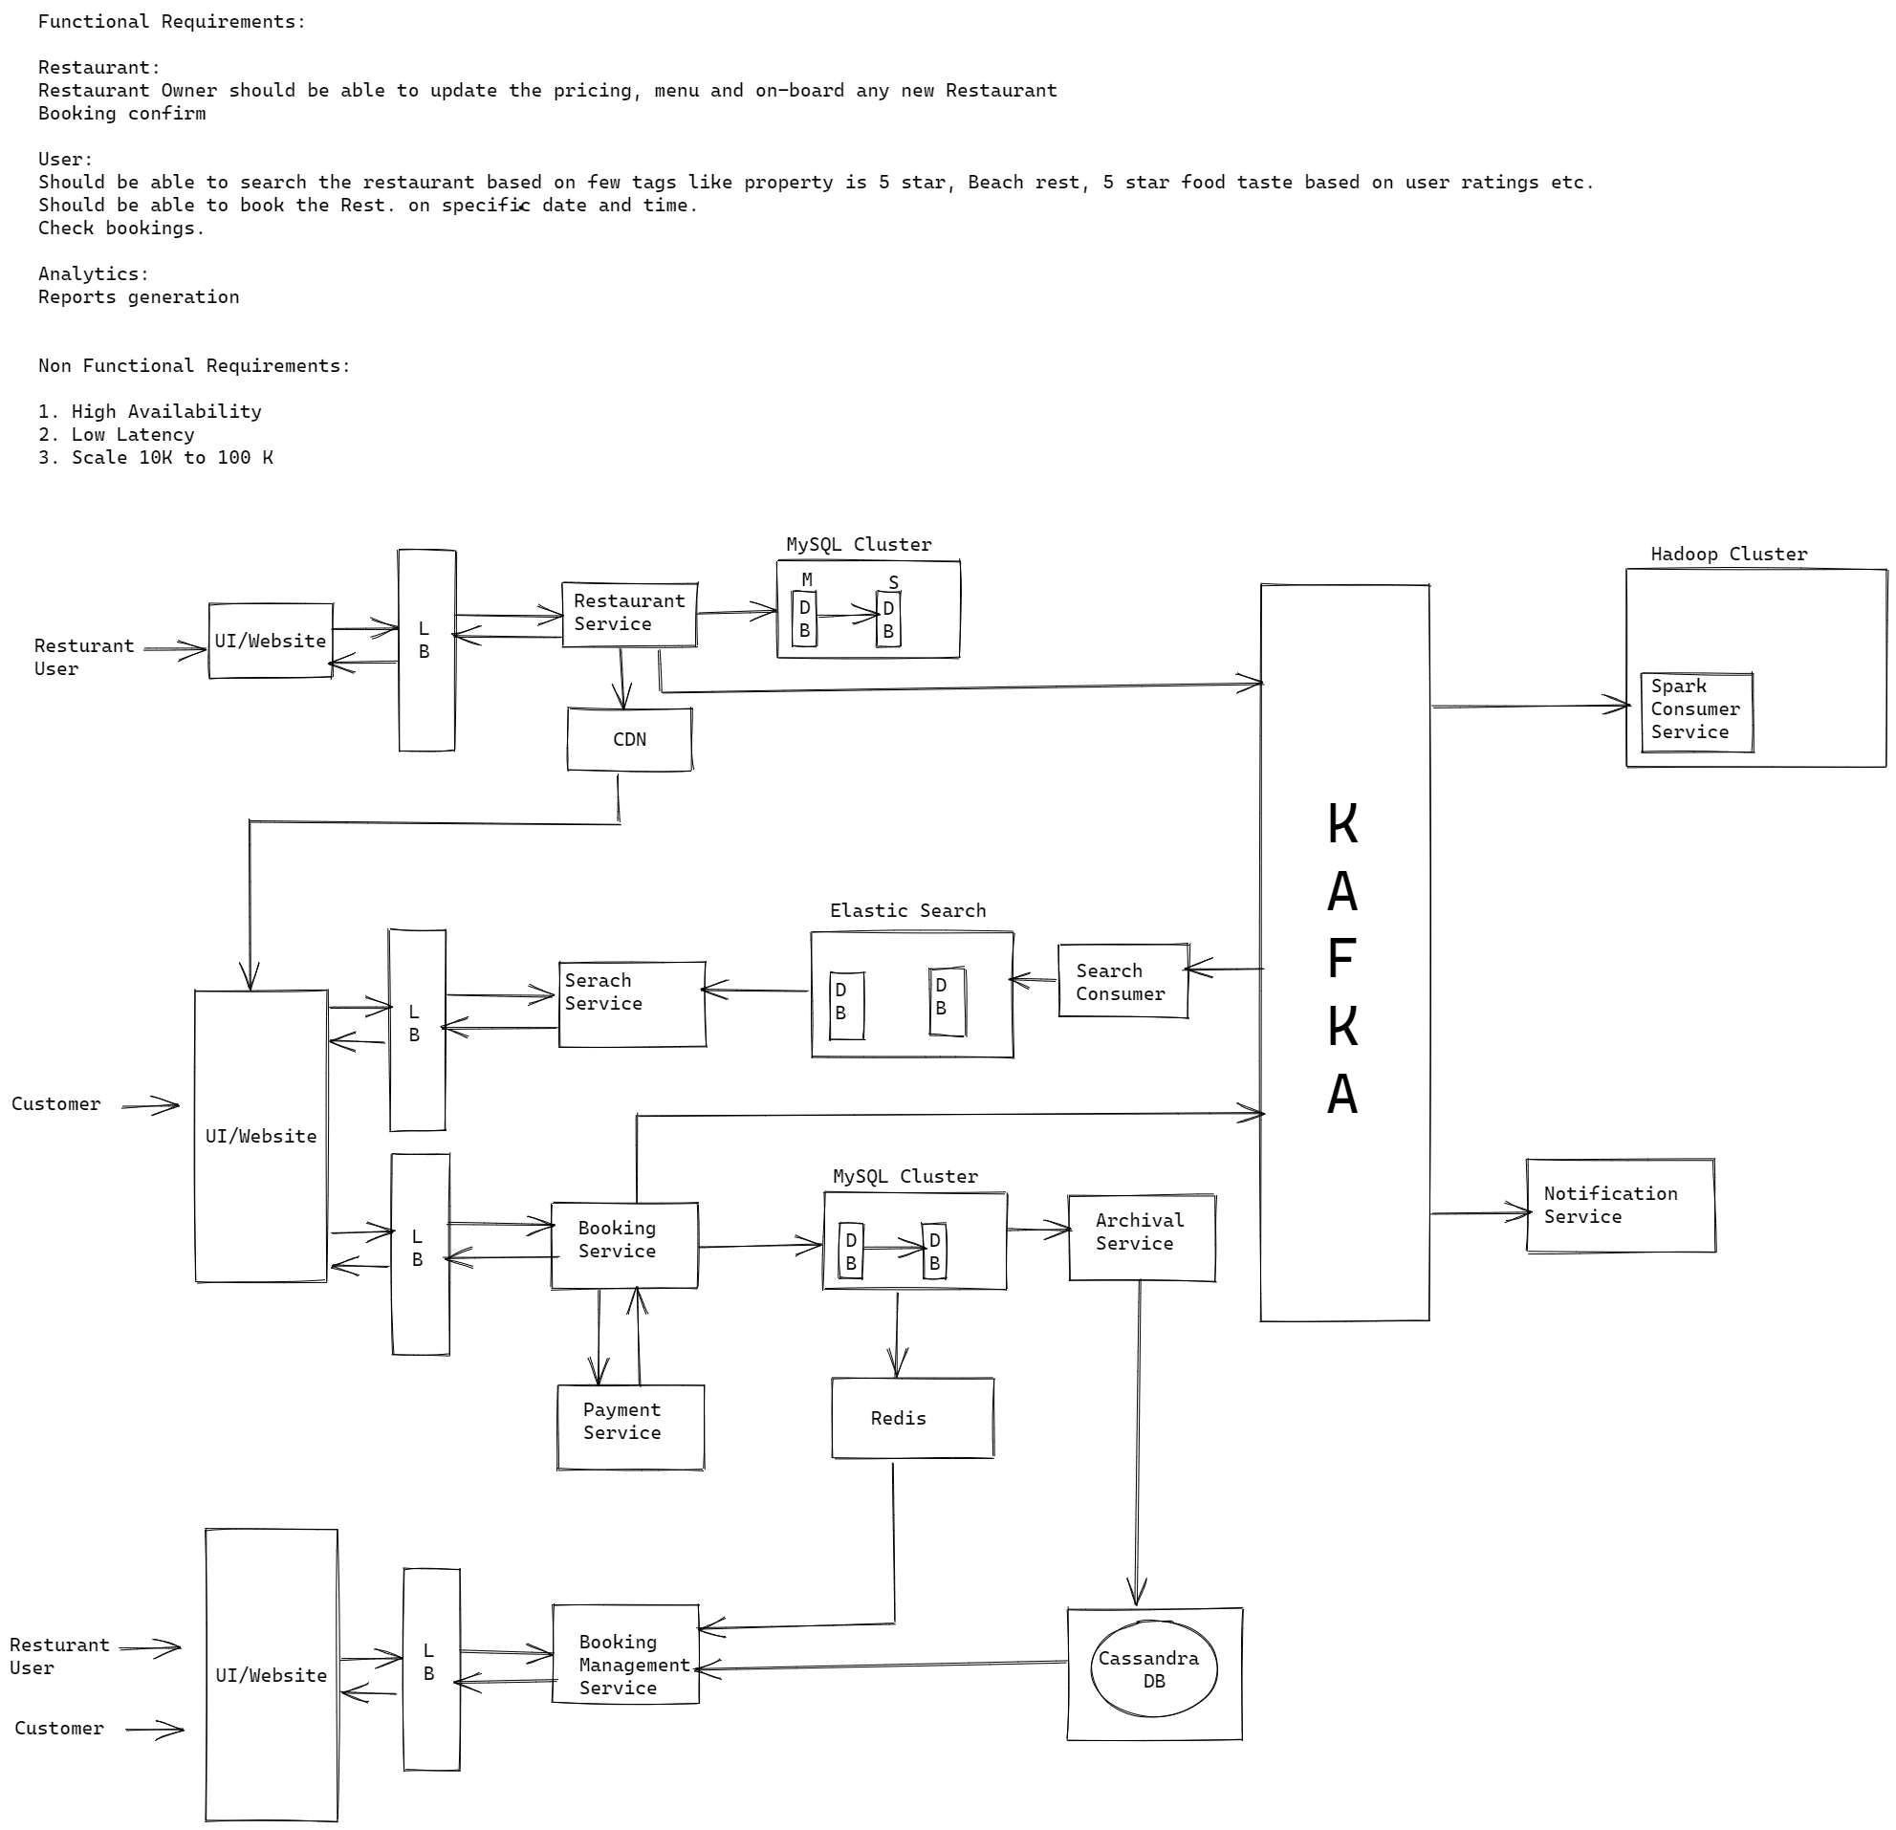

**Restaurant API’s:**

Get : /Restaurants/id

Post : /Restaurants

Put : /Restaurants/id/Menu/id

Delete: /Restaurants/id

